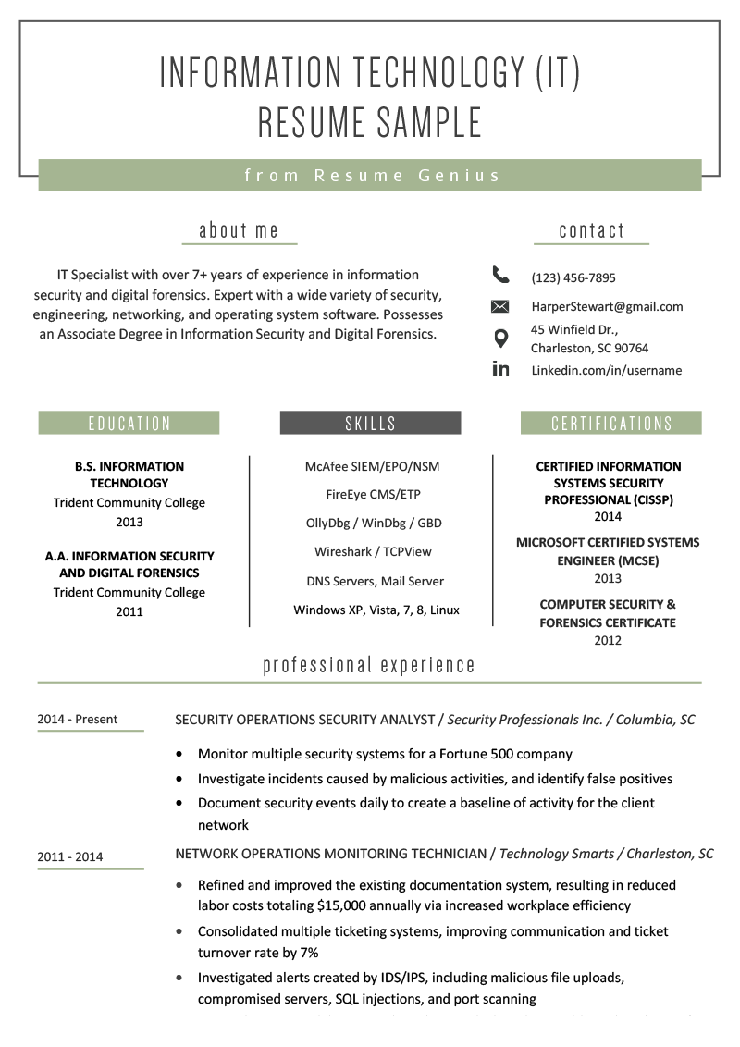
INFORMATION TECHNOLOGY (IT) RESUME SAMPLE
from Resume Genius
about me
IT Specialist with over 7+ years of experience in information security and digital forensics. Expert with a wide variety of security, engineering, networking, and operating system software. Possesses an Associate Degree in Information Security and Digital Forensics.
O
in
contact
(123) 456-7895
HarperStewart@gmail.com
45 Winfield Dr.,
Charleston, SC 90764
EDUCATION
B.S. INFORMATION
TECHNOLOGY
Trident Community College 2013
A.A. INFORMATION SECURITY AND DIGITAL FORENSICS Trident Community College 2011
2014 - Present
2011 - 2014
SKILLS
McAfee SIEM/EPO/NSM
FireEye CMS/ETP OllyDbg/WinDbg/GBD
Wireshark/TCPView
DNS Servers, Mail Server Windows XP, Vista, 7, 8, Linux
professional experience
Linkedin.com/in/username
CERTIFICATIONS
CERTIFIED INFORMATION SYSTEMS SECURITY PROFESSIONAL (CISSP) 2014
MICROSOFT CERTIFIED SYSTEMS ENGINEER (MCSE) 2013
COMPUTER SECURITY & FORENSICS CERTIFICATE
2012
SECURITY OPERATIONS SECURITY ANALYST/Security Professionals Inc./Columbia, SC
• Monitor multiple security systems for a Fortune 500 company
• Investigate incidents caused by malicious activities, and identify false positives
• Document security events daily to create a baseline of activity for the client network
NETWORK OPERATIONS MONITORING TECHNICIAN/Technology Smarts/Charleston, SC
• Refined and improved the existing documentation system, resulting in reduced labor costs totaling $15,000 annually via increased workplace efficiency
• Consolidated multiple ticketing systems, improving communication and ticket turnover rate by 7%
• Investigated alerts created by IDS/IPS, including malicious file uploads,
compromised servers, SQL injections, and port scanning

